(WEEK - 3 HANDSON EXERCISE)

YASH RAJ

SUPERSET ID - 6364442

Lab 1: Understanding ORM with a Retail Inventory System Scenario:

You’re building an inventory management system for a retail store. The store wants to
track products, categories, and stock levels in a SQL Server database.

Objective:
Understand what ORM is and how EF Core helps bridge the gap between C# objects and
relational tables

Steps:
1. What is ORM?
• Explain how ORM maps C# classes to database tables.

Ans:
ORM maps object-oriented code (C# classes) to relational database structures (tables). This process is called object-relational mapping.

How Mapping Works in Entity Framework:

Class to Table:

Each C# class becomes a table in the database.

public class Student
{
public int StudentId { get; set; }
public string FirstName { get; set; }
public string LastName { get; set; }
}

Maps to this SQL Table:

CREATE TABLE Students (
StudentId INT PRIMARY KEY,
FirstName NVARCHAR(MAX),
LastName NVARCHAR(MAX)
);

Property maps to Column:
Each property of the class maps to a column in the table.

Primary Key Identification
EF automatically identifies a primary key if:

Property is named Id

Or: <ClassName>Id (e.g., StudentId in Student)

Relationships Mapping
EF uses navigation properties and conventions or attributes to define relationships.

One-to-Many Example:

public class Student
{
public int StudentId { get; set; }
public ICollection<Enrollment> Enrollments { get; set; }
}

public class Enrollment
{
public int EnrollmentId { get; set; }
public int StudentId { get; set; }
public Student Student { get; set; }
}

This will create:
Students table
Enrollments table with StudentId as foreign key.

. DbContext as the Bridge
Your DbContext tells EF which classes to treat as entities (tables):

using Microsoft.EntityFrameworkCore;

public class AppDbContext : DbContext
{
public DbSet<Student> Students { get; set; }
public DbSet<Enrollment> Enrollments { get; set; }
}

- Benefits: Productivity, maintainability, and abstraction from SQL.

Ans:

1. Productivity
ORMs like Entity Framework help developers build data-driven applications faster by eliminating a lot of boilerplate code.

a ) Automatically generates SQL for common operations (INSERT, SELECT, UPDATE, DELETE).

b) Handles relationships and joins via navigation properties.

2. Maintainability
A ) EF keeps your data model in sync with your application logic, making code easier to understand and update.

B ) Strongly typed: C# compiler catches errors at compile time (e.g., mistyped column/property names).

C ) Centralized model definitions make it easier to track changes.

- Easier to refactor your model classes (e.g., rename properties safely).

- Manual SQL: Renaming a column = updating every raw SQL string.

- : Rename a C# property, and EF migration will track it automatically.

3. Abstraction from SQL
Entity Framework lets you focus on business logic instead of query syntax.

A ) You write C# (LINQ) queries instead of SQL.

B ) You don't need deep SQL knowledge to work with databases.

C )EF handles connection pooling, transactions, and parameterization safely.

D )Reduces need for manual database access code (e.g., ADO.NET, SqlCommand).

3. EF Core vs EF Framework:
• EF Core is cross-platform, lightweight, and supports modern features like
LINQ, async queries, and compiled queries.
• EF Framework (EF6) is Windows-only and more mature but less flexible.

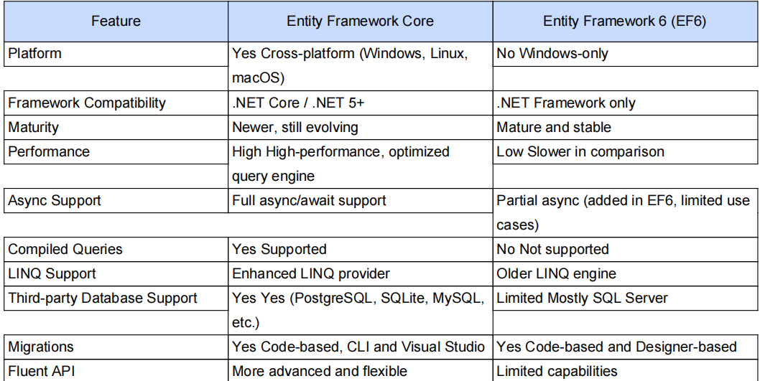

4 ) EF Core 8.0 Features:

Ans :

JSON column mapping.
Improved performance with compiled models.
Interceptors and better bulk operations.

5. Create a .NET Console App:
dotnet new console -n RetailInventory
cd RetailInventory

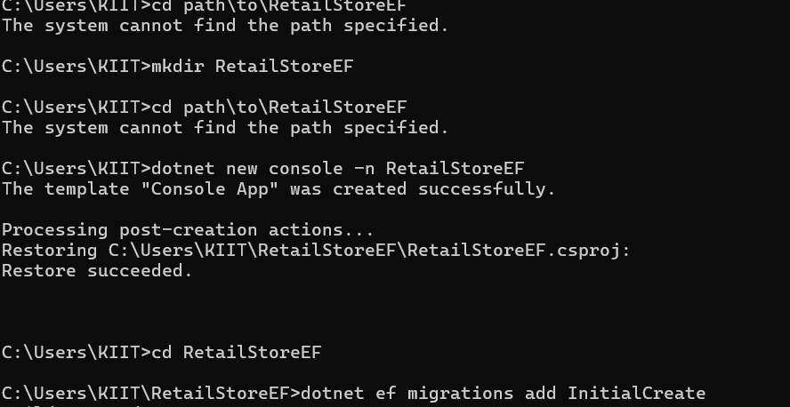

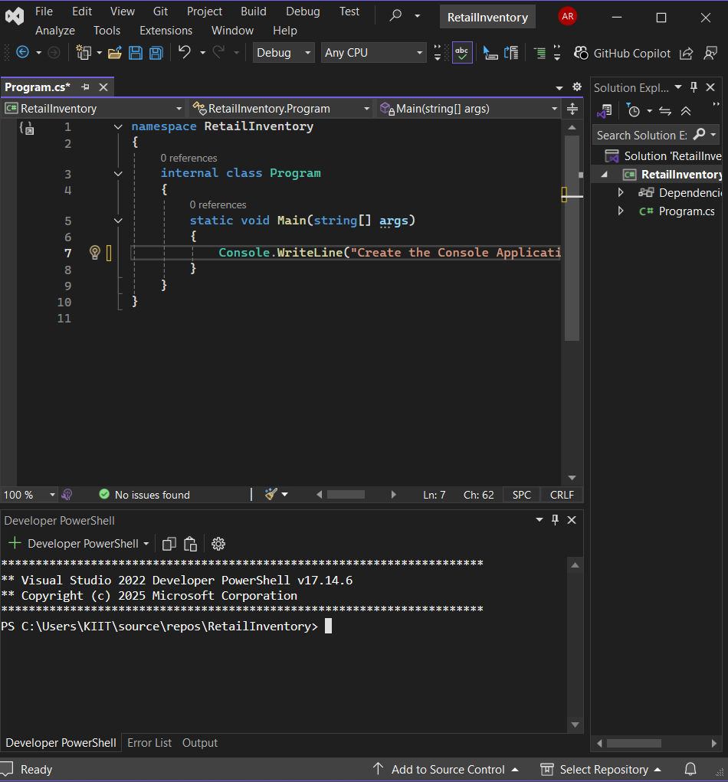

5. Install EF Core Packages:
dotnet add package Microsoft.EntityFrameworkCore.Design

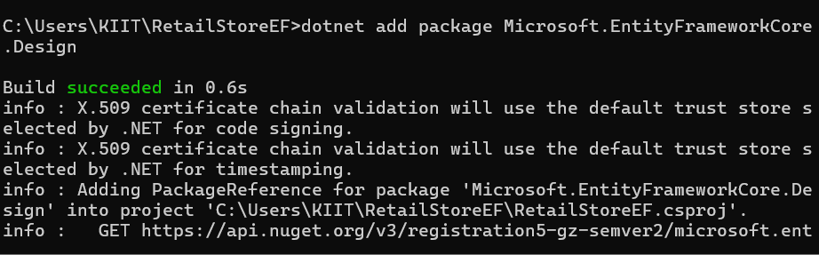

dotnet add package Microsoft.EntityFrameworkCore.SqlServer

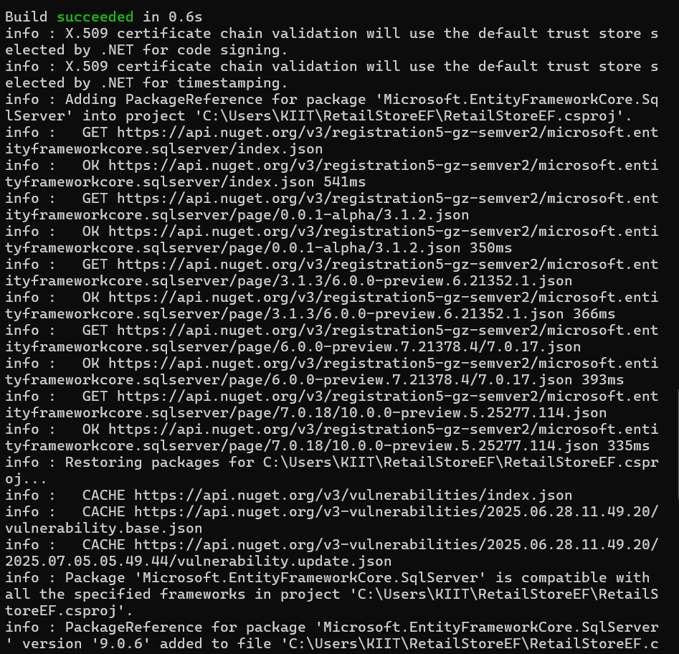

Lab 2

: Setting Up the Database Context for a Retail Store
Scenario:
The retail store wants to store product and category data in SQL Server.
Objective:
Configure DbContext and connect to SQL Server.
Steps:

1. Create Models:
public class Category {
public int Id { get; set; }
public string Name { get; set; }
public List Products { get; set; }
}
public class Product {
public int Id { get; set; }
public string Name { get; set; }
public decimal Price { get; set; }
public int CategoryId { get; set; }
public Category Category { get; set; }
}

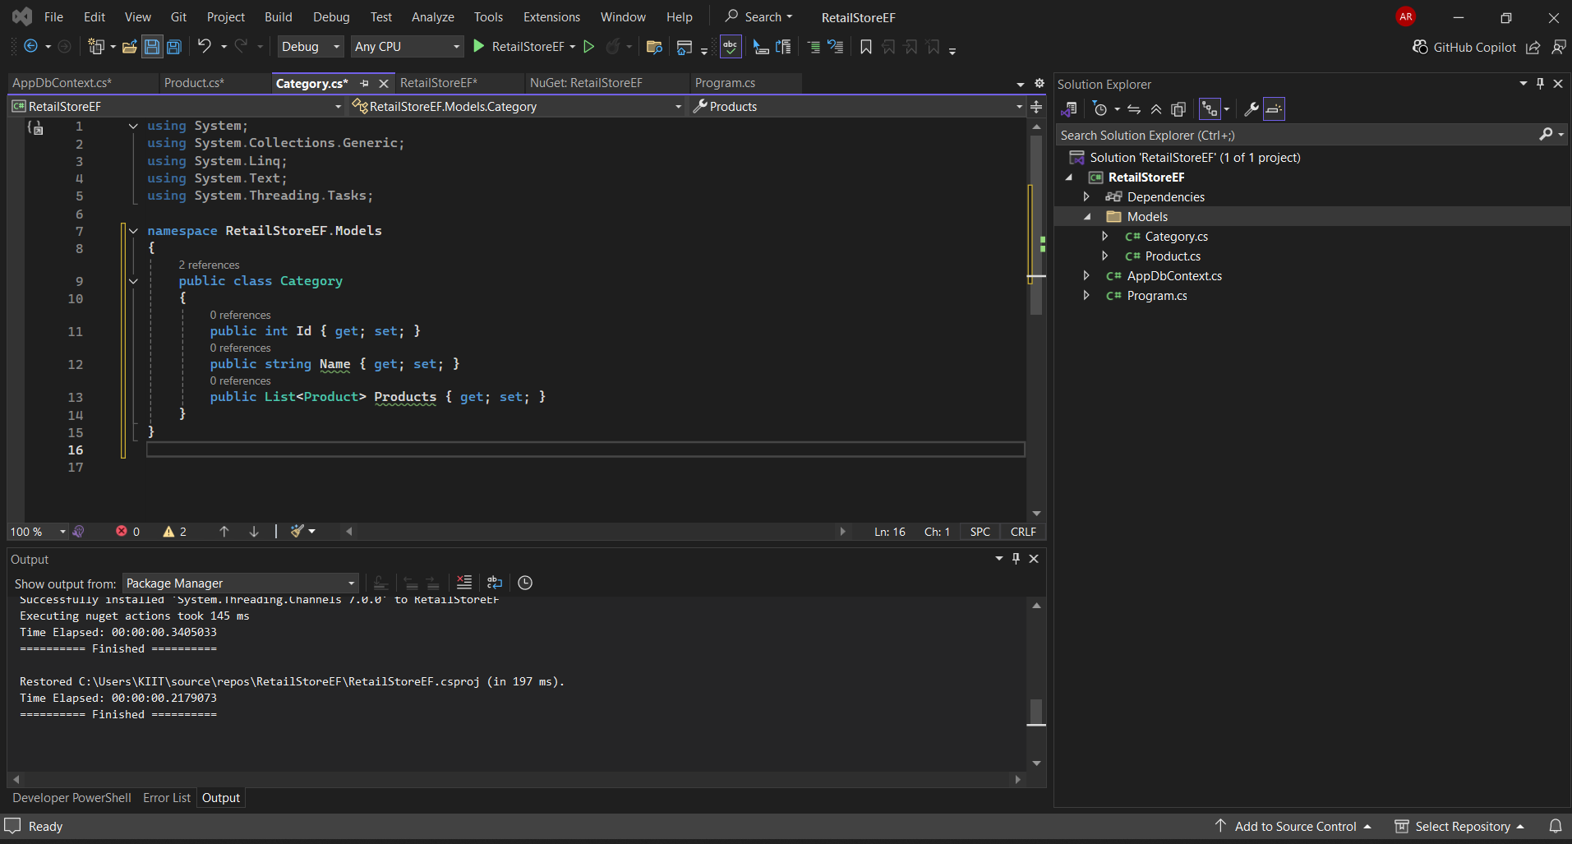

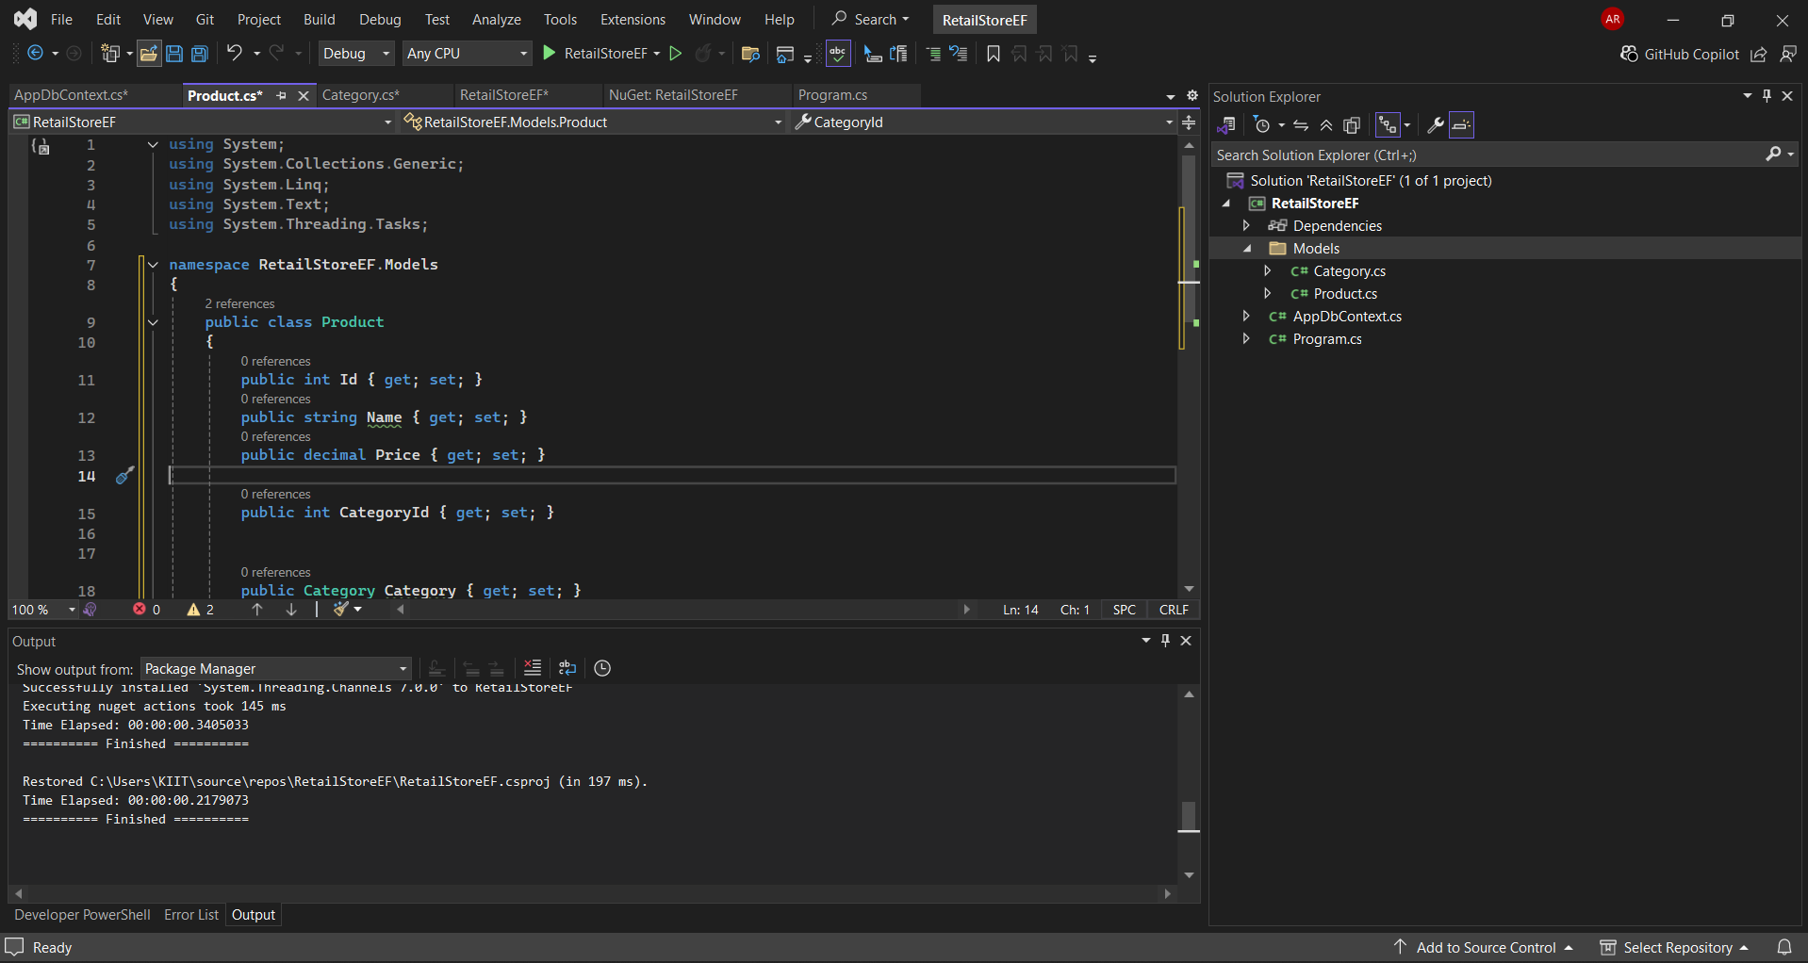

2. Create AppDbContext:
public class AppDbContext : DbContext {
public DbSet Products { get; set; }
public DbSet Categories { get; set; }
protected override void OnConfiguring(DbContextOptionsBuilder optionsBuild
er) {
optionsBuilder.UseSqlServer("Your_Connection_String_Here");
}
}

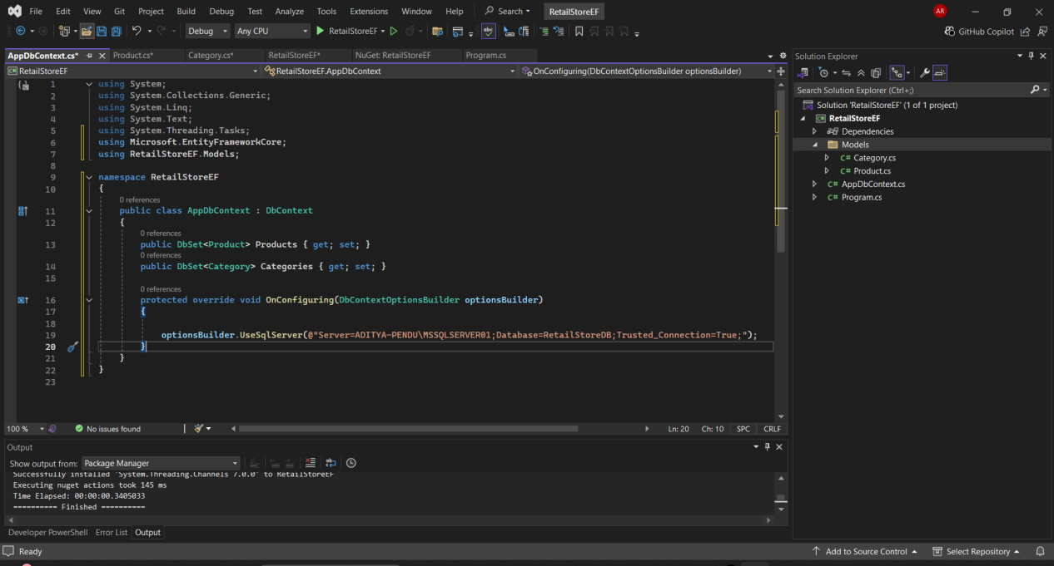

- Add Connection String in appsettings.json (optional for ASP.NET Core).
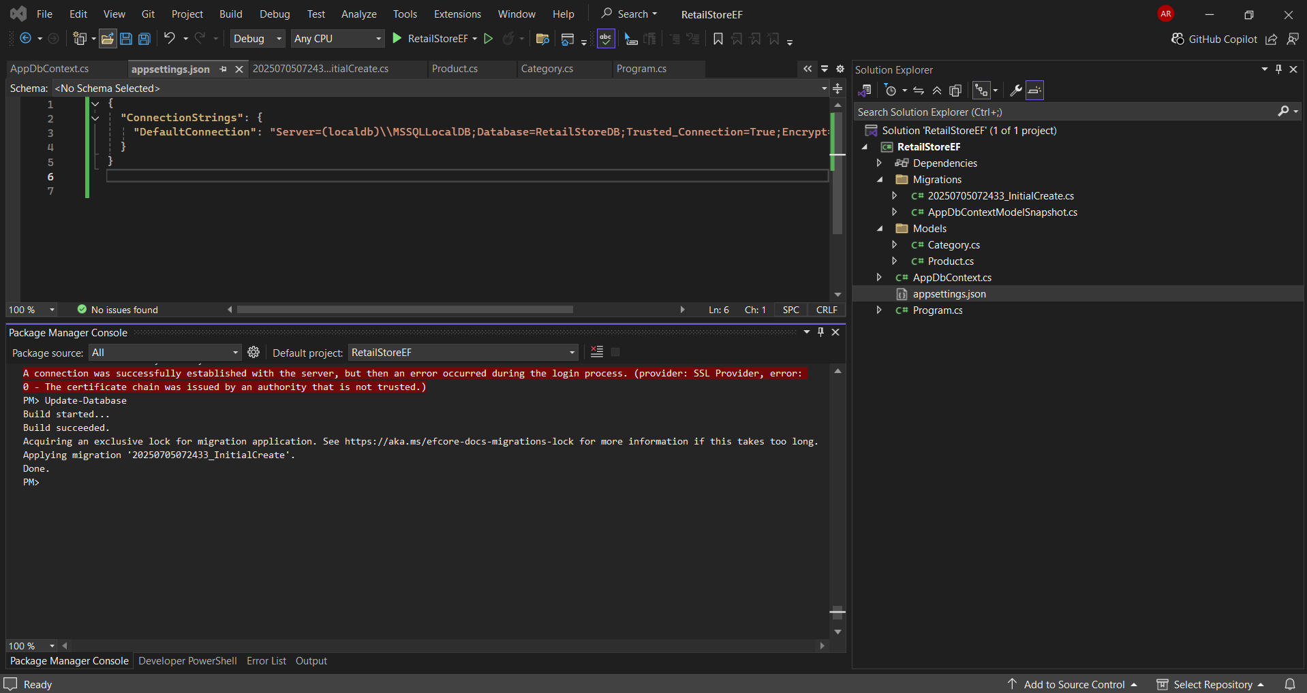

Lab 3:

Using EF Core CLI to Create and Apply Migrations
Scenario:
The retail store's database needs to be created based on the models you've defined.
You’ll use EF Core CLI to generate and apply migrations.
Objective:
Learn how to use EF Core CLI to manage database schema changes.
Steps:
1. Install EF Core CLI (if not already):
dotnet tool install --global dotnet-ef

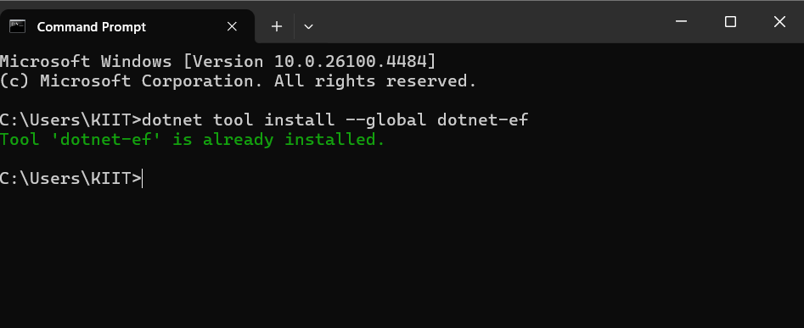
2. Create Initial Migration:
dotnet ef migrations add InitialCreate
This generates a Migrations folder with code that represents the schema.

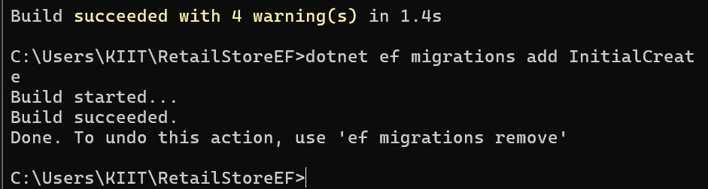

3. Apply Migration to Create Database:
dotnet ef database update
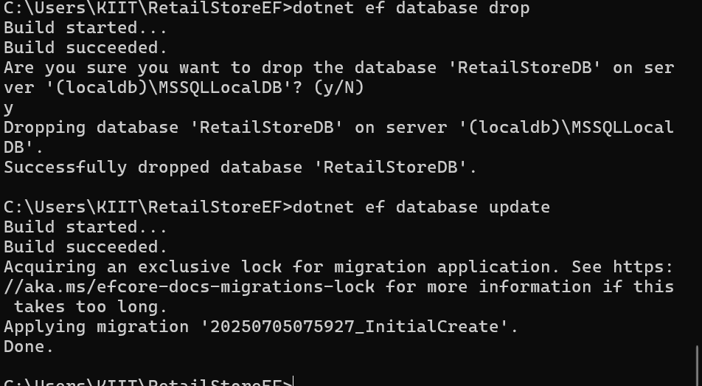

4. Verify in SQL Server:
Open SQL Server Management Studio (SSMS) or Azure Data Studio and confirm
that tables Products and Categories are created.

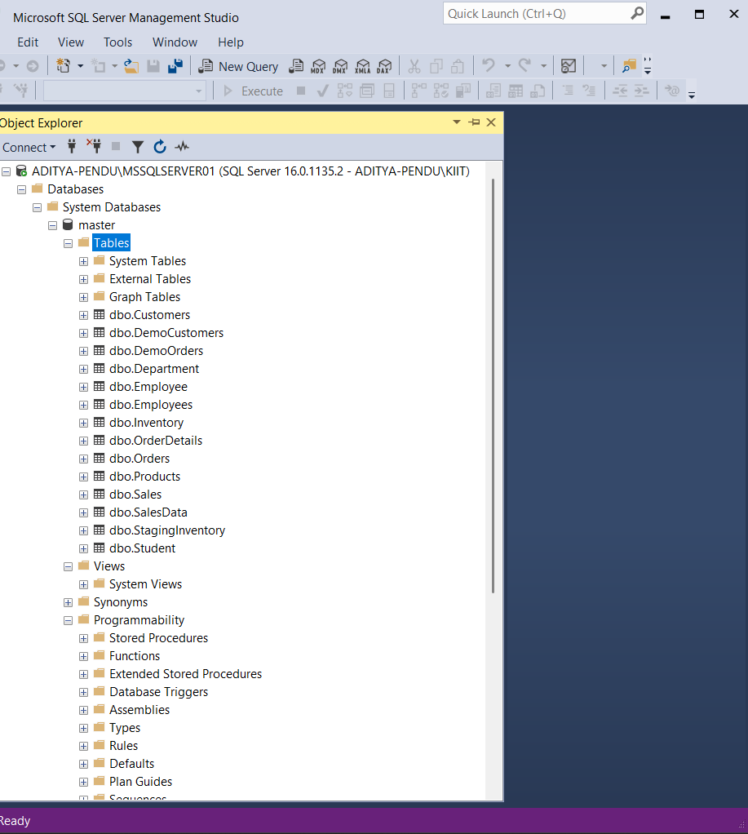

Lab 4: Inserting Initial Data into the Database
Scenario:
The store manager wants to add initial product categories and products to the system.
Objective:
Use EF Core to insert records using AddAsync and SaveChangesAsync.
Steps:
1. Insert Data in Program.cs:
using var context = new AppDbContext();
var electronics = new Category { Name = "Electronics" };
var groceries = new Category { Name = "Groceries" };
await context.Categories.AddRangeAsync(electronics, groceries);
var product1 = new Product { Name = "Laptop", Price = 75000, Category = electro
nics };
var product2 = new Product { Name = "Rice Bag", Price = 1200, Category = groceri
es };
await context.Products.AddRangeAsync(product1, product2);
await context.SaveChangesAsync();
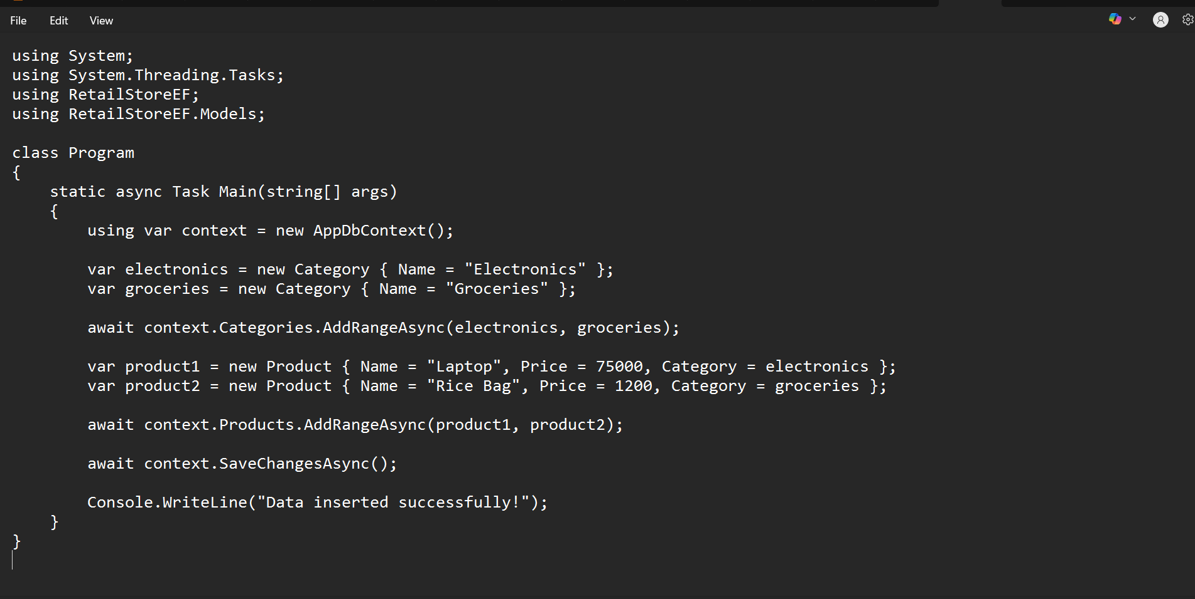
2. Run the App:
dotnet run
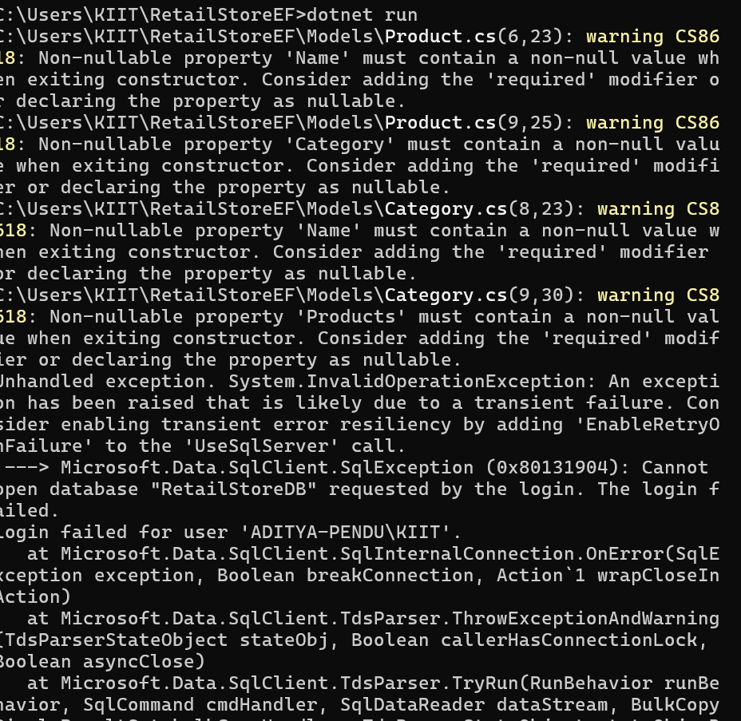

3. Verify in SQL Server:
Check that the data is inserted correctly

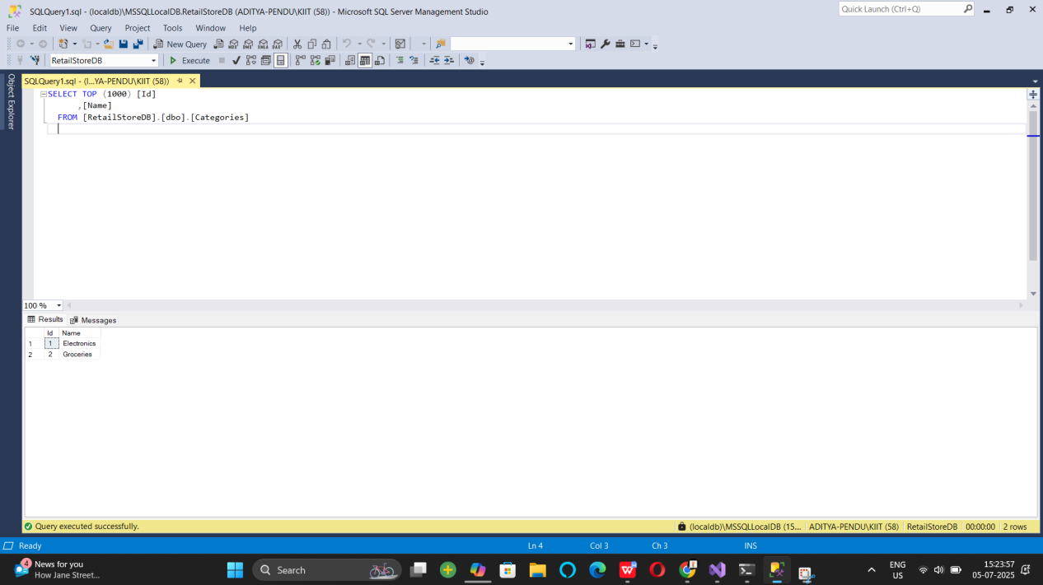

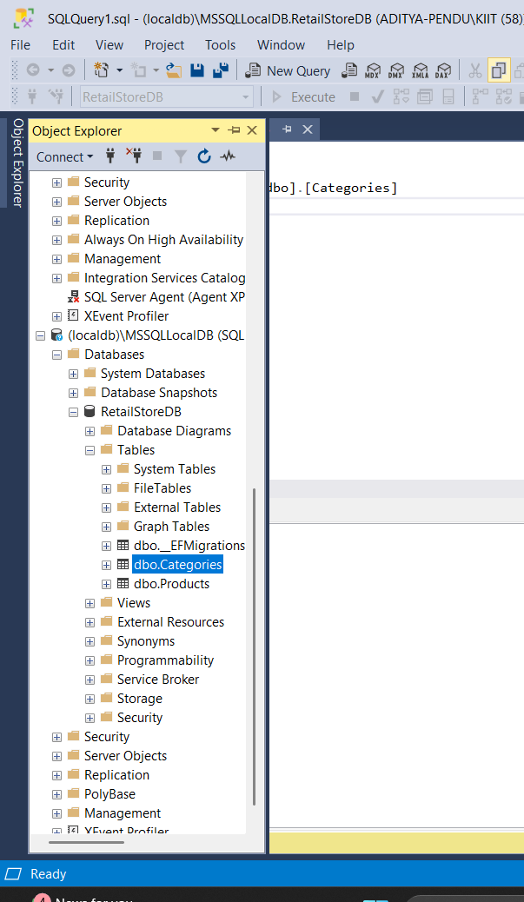

Lab 5:

Lab 5: Retrieving Data from the Database
Scenario:
The store wants to display product details on the dashboard.
Objective:
Use Find, FirstOrDefault, and ToListAsync to retrieve data.
Steps:
1. Retrieve All Products:
var products = await context.Products.ToListAsync();
foreach (var p in products)
Console.WriteLine($"{p.Name} - ₹{p.Price}");

using System;
using System.Threading.Tasks;
using System.Linq;
using Microsoft.EntityFrameworkCore;
using RetailStoreEF;
using RetailStoreEF.Models;

class Program
{
static async Task Main(string[] args)
{
using var context = new AppDbContext();

// 1. Retrieve all products
var products = await context.Products.ToListAsync();
Console.WriteLine("🛍 All Products:");
foreach (var p in products)
Console.WriteLine($"{p.Name} - ₹{p.Price}");

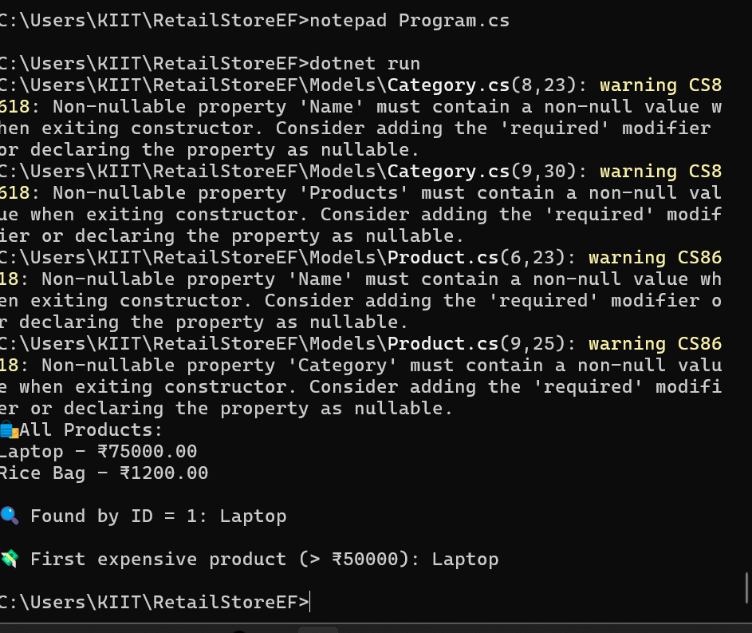

2. Find by ID:
var product = await context.Products.FindAsync(1);
Console.WriteLine($"Found: {product?.Name}");

// 2. Find by ID
var product = await context.Products.FindAsync(1);
Console.WriteLine($"\ Found by ID = 1: {product?.Name}");


3. FirstOrDefault with Condition:
var expensive = await context.Products.FirstOrDefaultAsync(p => p.Price > 5000
0);
Console.WriteLine($"Expensive: {expensive?.Name}")

// 3. FirstOrDefault with condition
var expensive = await context.Products.FirstOrDefaultAsync(p => p.Price > 50000);
Console.WriteLine($"\n💸 First expensive product (> ₹50000): {expensive?.Name}");
}





Lab 6

Updating and Deleting Records
Scenario:
The store updates product prices and removes discontinued items.
Objective:
Update and delete records using EF Core.
Steps:
1. Update a Product:
var product = await context.Products.FirstOrDefaultAsync(p => p.Name == "Lapt
op");
if (product != null) {
product.Price = 70000;
await context.SaveChangesAsync();
}

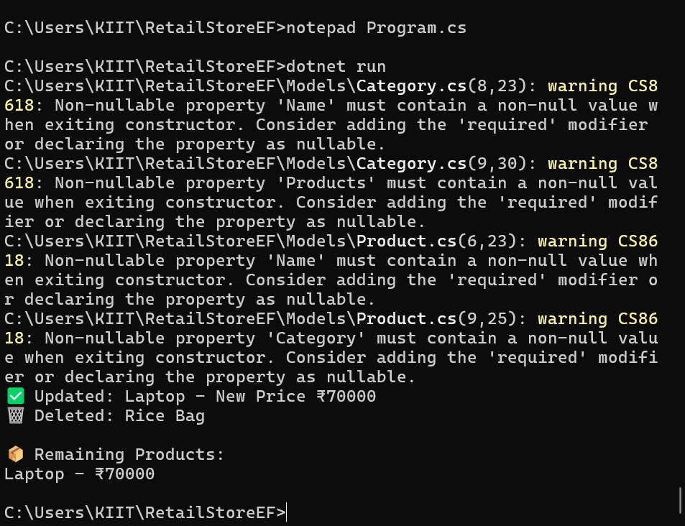
2. Delete a Product:
var toDelete = await context.Products.FirstOrDefaultAsync(p => p.Name == "Rice
Bag");
if (toDelete != null) {
context.Products.Remove(toDelete);
await



Lab 7

: Writing Queries with LINQ
Scenario:
The store wants to filter and sort products for reporting.
Objective:
Use Where, Select, OrderBy, and project into DTOs.
Steps:
1. Filter and Sort:
var filtered = await context.Products
.Where(p => p.Price > 1000)
.OrderByDescending(p => p.Price)
.ToListAsync();
2. Project into DTO:
var productDTOs = await context.Products
.Select(p => new { p.Name, p.Price })
.ToListAsync()

Ans:

using System;
using System.Linq;
using System.Threading.Tasks;
using Microsoft.EntityFrameworkCore;
using RetailStoreEF;
using RetailStoreEF.Models;

class Program
{
static async Task Main(string[] args)
{
using var context = new AppDbContext();

// FILTER and SORT: Products with Price > 1000, sorted descending
var filtered = await context.Products
.Where(p => p.Price > 1000)
.OrderByDescending(p => p.Price)
.ToListAsync();

Console.WriteLine(" Filtered & Sorted Products (Price > ₹1000):");
foreach (var p in filtered)
Console.WriteLine($"{p.Name} - ₹{p.Price}");

// PROJECT INTO DTO: Only Name and Price
var productDTOs = await context.Products
.Select(p => new { p.Name, p.Price })
.ToListAsync();

Console.WriteLine("\n🧾 Product DTOs:");
foreach (var dto in productDTOs)
Console.WriteLine($"Name: {dto.Name}, Price: ₹{dto.Price}");
}
}

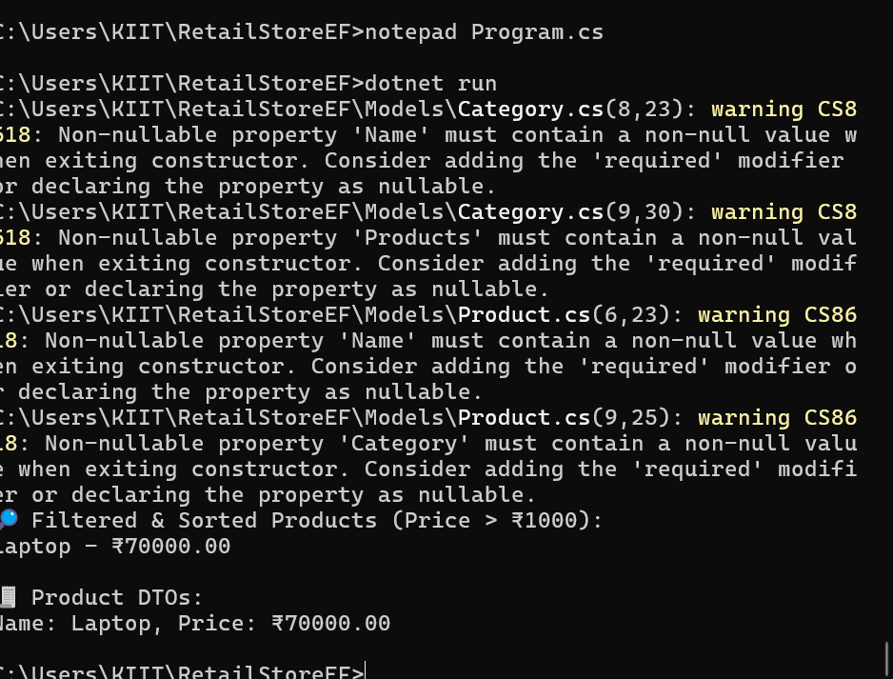

Lab 8

: Managing Migrations and Schema Changes
Scenario:
The store wants to add a new field StockQuantity to track inventory levels for each
product.
Objective:
Learn how to update the schema using EF Core migrations.
Steps:
1. Update the Product Model:
public int StockQuantity { get; set; }
2. Create a New Migration:
dotnet ef migrations add AddStockQuantity
3. Apply the Migration:
dotnet ef database update
4. Verify in SQL Server:
Confirm that the StockQuantity column is added

